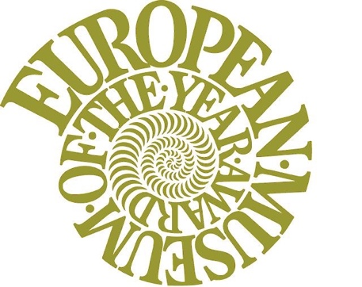 | 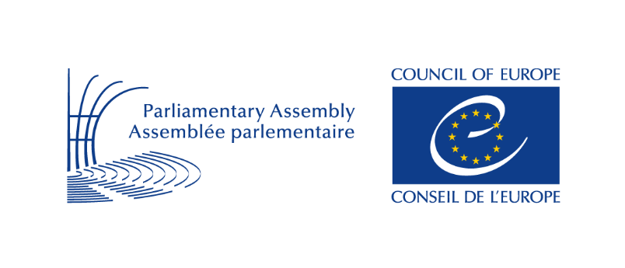
European Museum of the Year Award (EMYA)
Council of Europe Museum Prize
2022
Application Form
Please return/upload this form by 30 April 2021
YOUR PUBLIC IMAGE AND HOW THE PUBLIC CONTACTS YOU.
Please note that these details will be published in the official EMYA 2022 Candidates Brochure.
Museum Name (the full, formal, legal name)

Museum Name in English (the official translation if different from above)

Address for visitors (the actual, physical location of the museum):

Full postal address for public enquiries (if different to above):

Museum Website: |  | Email address for public enquiries:
Telephone number for public enquiries (including international code):

Museum presence in social networks: |  | Museum Director:
INFORMATION ABOUT YOUR MUSEUM
Date that the new museum opened to the public: |  | Date the museum opened after renovation or re-development:
What has been renovated or re-developed? (FAQ 17)

Type of museum (FAQ 1): |  | Owner / Legal Status of the museum (FAQ 2):
How is the museum funded (FAQ 3): |  | Please confirm that the museum is not for profit:
Annual budget of the museum for the most recently completed financial year: |  | Form of governance of the museum (FAQ 4):
Mission Statement of the museum (please summarise the museum’s aims and objectives in no more than 150 words):

Opening times (times of the day, week and year that the museum is open to the public):

Entrance fee, in Euro (including any reduced fees for visitors):
Full price:
Reduced price:
Group (adults):
Group (children, seniors, students):

Short description of the museum buildings (no more than 150 words):

Museum facilities (please describe facilities available to the visitor, including café, shop, toilets, parking, access for the disabled etc.)

Total space of the buildings, in m²:

Total space available to the public, in m²: |  | Exhibition space, in m²:
Percentage of the public space refurbished (if not the whole museum):
Number of objects on display: |  | Number of objects in storage:
Profile of the collection (FAQ 5): |  | State of registration and conservation of collections (FAQ 6):
Total cost of new building, in Euros (if applicable): |  | Total cost of the redevelopment, in Euros:
How was the museum or redevelopment financed? (FAQ 7)

Major external partners involved in the creation or redevelopment of the museum (FAQ 8):

Annual number of visitors before renovation or redevelopment (if applicable): |  |  | Annual number of visitors since opening, or after renovation or redevelopment:
Profile or distribution of visitors, if known:

Number of permanent employees: |  |  | Number of temporary employees:
Organisation of the Museum (FAQ 9): |  |  | Distribution of staff on basic Museum functions (If you have a staff organisational chart (sometimes called an organogram) please attach it to your application and note its attachment here).
Outreach projects or other strategies for audience development:

Short description of the role of voluntary work in your organisation: (including numbers and activities undertaken):

Explain briefly:
- your vision and mission in public quality (FAQ 16)

- the innovations, taking into account your context, in public quality

- the involvement of the local community, special target groups and/or volunteers

- the European perspective or significance of your project

- how you are using technology to support the museum's work

- initiatives you have taken in the field of environmental and social sustainability (FAQ 10)

Have you applied for EMYA and the Council of Europe Museum Prize before? If the answer is yes, please tell us when:

Please tell us how you found out about EMYA and the Council of Europe Museum Prize 2022:

Please provide a maximum of 20 digital images, in JPEG format:
These images should be no less than 300 dpi and be at least 1000×1000 pixels in size. The image files must be of a suitable quality for reproduction and projection and each image must be given a unique file name. The images should include at least one exterior view of the museum and general views of the galleries and activities. We do not require images of individual items.
Please note that these images will be used by the EMF in a number of ways, including publication of a selection in the annual candidates’ brochure. The images must be of a good quality, free of copyright and available for use in the Annual EMYA publications and on the EMF web site.
Any other digital material which you may wish to send to us separately.
This could include electronic versions of the Museum’s leaflets, brochures or catalogues and a small selection of relevant press cuttings.
If you intend to submit other supporting material via a file-sharing website you should send EMF a notification of the upload (to emf@europeanforum.museum) and also ensure that the files will be available for download by us for at least one month from the date you upload the files. We would appreciate the upload of complete folders rather than multiple uploads of individual files.
A content list of all accompanying material must be sent to us.
Please note: All paper and electronic material will be retained in the EMF Archive after the judging has taken place. The archive is held at the Museu de Portimão in Portugal.
Description of the project.
In a separate document of no more than two A4 pages, please provide a more detailed description of the project. You should focus on what you consider to be the ‘public quality’ of the museum (FAQ 16). Please also include details about the project’s method of financing – stating clearly if your organisation is ‘not for profit’ or is a commercial enterprise. You may also tell us about your future plans for the Museum. It is important that this document be no more than two A4 pages and be written in English, in Word format.
Additionally, please make a brief summary of the project in no more than about 200 words. If your museum is nominated, this will be used as the basis for the description of your museum on the EMF website and the Candidates Brochure.
HOW THE EMF SHOULD CONTACT YOU. The following details will only be used to contact you about your application and will be kept confidential by the EMF.
Primary Contact for EMF queries (if different to Director). This should be a named person responsible for all communication between the museum and the EMF. Please include his or her job title, telephone number and email details in the spaces provided below.
Name and Job title:
Email address: |  |  | Telephone number (including international code):
Director’s contact details:

Terms of Agreement
The candidate is acquainted with the procedures and terms in the Guidelines.
Please note that the deadline for submission is Thursday 30 April 2021. Your application must reach us by midnight on this date. Late applications will not be considered.
For further queries, please contact Pedro Branco EMF Administrator, at emf@europeanforum.museum
European Museum Forum is a Charitable Company Limited by guarantee, registered in England and Wales, registration no 07243034, charity no 1136790, registered office World Museum Liverpool, William Brown Street, Liverpool L3 8EN www.europeanmuseum.forum

